Lewis University  
CPSC 50900: Database Systems  
Term Project

Commodity possession in relationship with employment

Pranay Reddy Lingapuram, pranayreddylingapu@lewisu.edu

Srinivasa Rao Medisetti, smedisetti2806@lewisu.edu

https://github.com/Pranay4683

Table of Contents

Initial Proposal 2

Data Sources 2

Data Storage Alternatives 2

Relational Database Design Process 3

Relational Database Design 3

Data Definition Language (DDL) Scripts 3

Data Manipulation Language Scripts 4

Indexes 5

Views 5

Triggers 5

Transactions 5

Database Security 6

Locking and Concurrent Access 6

Backing Up Your Database 6

Python Programming 7

PHP Programming 7

Suggested Future Work 8

Activity Log 8

# Initial Proposal

We want to store the data of different countries wherein how many people are unemployed and how many people own cars. We want to figure out what is the ratio between having a job and buying a car. The data will come from [Industrial Commodity Statistics Database](https://data.un.org/Data.aspx?q=cars&d=ICS&f=cmID%3a49113-0#ICS) and  [International Labour Organization](http://www.ilo.org/stat/)   
 We plan on building informative application.

Title: Commodity possession in relationship with employment

# Data Sources

**Data sources:** <https://data.un.org/Data.aspx?q=people&d=LABORSTA&f=tableCode%3a3A%3bcountryCode%3aLA#LABORSTA>

[*https://data.un.org/Data.aspx?q=cars&d=ICS&f=cmID%3a49113-0*](https://data.un.org/Data.aspx?q=cars&d=ICS&f=cmID%3a49113-0)

*Data files contain records of number of cars bought by countries in respective years and how many people were unemployed during that time period*

*Data of car contains number of units sold(int), country(string), year(date), value(int)*

*Data of unemployment file contain country(int), year(date), sex(string), coverage(string), source, type(skip), value(skip)*

*Data is structured according to countries and years of collection.*

*I will include countries, year of survey, sex, number of cars sold, number of people unemployed*

*I Will add primary key of country in all relations.*

# Data Storage Alternatives

**Network Data Model:**  
The network database model was created to solve the shortcomings of the hierarchical database model. In this type of model, a child can be linked to multiple parents, a feature that was not supported by the hierarchical data model. The parent nodes are known as owners and the child nodes are called members.

**Advantages:**  
This model is very simple and easy to design like the hierarchical data model.

In this model, we can access the data easily, and also there is a chance that the application can access the owner’s and the member’s records within a set.

Like a hierarchical model, this model also does not have any database standard.

**Disadvantages:**

The schema or the structure of this database is very complex in nature as all the records are maintained by the use of pointers.

There’s an existence of operational anomalies as there is a use of pointers for navigation which further leads to complex implementation.

This model does not have any scope of automated query optimization.

**NoSQL data model:**  
NoSQL essentially describes a grouping of philosophical database design blueprints that avoid relationship data storage. It stores the data as flat files.

**Advantages:**  
NoSQL is faster then relational databases.

Expansion is incredibly cheap, easy, compared to SQL

It is flexible and changes are easy to make.

**Disadvantages:**  
It is not yet mature compared to relational data models.

Its speed is largely dependent on computational power of the system.

# Relational Database Design Process

Country,Year->Unit,Value

Country, Year, Sex, Source->Value

Names of Entities:  
Country

Unemployed

Car owner

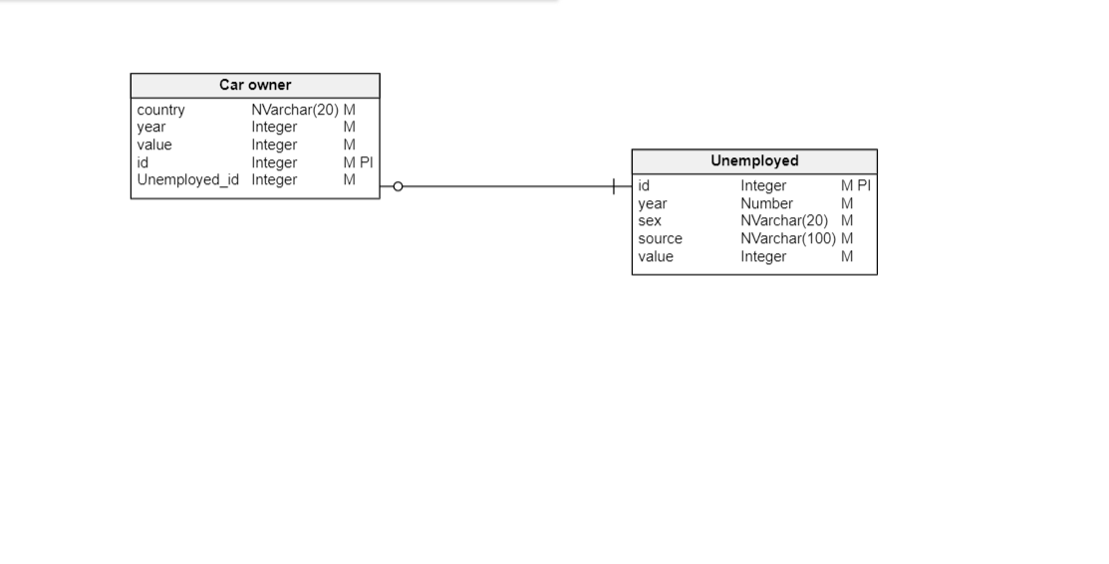

# Relational Database Design

4th normal form  
Physical model:  
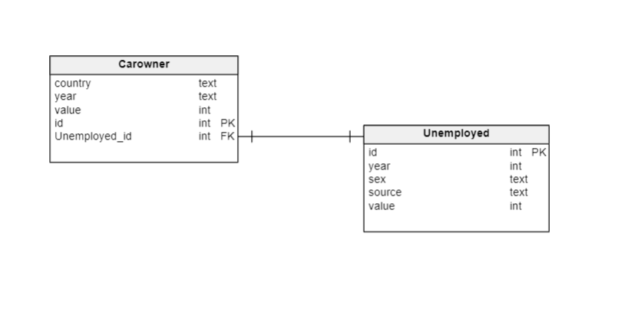

# Data Definition Language (DDL) Scripts

The script created are used to create tables in database and also define relationship among them.

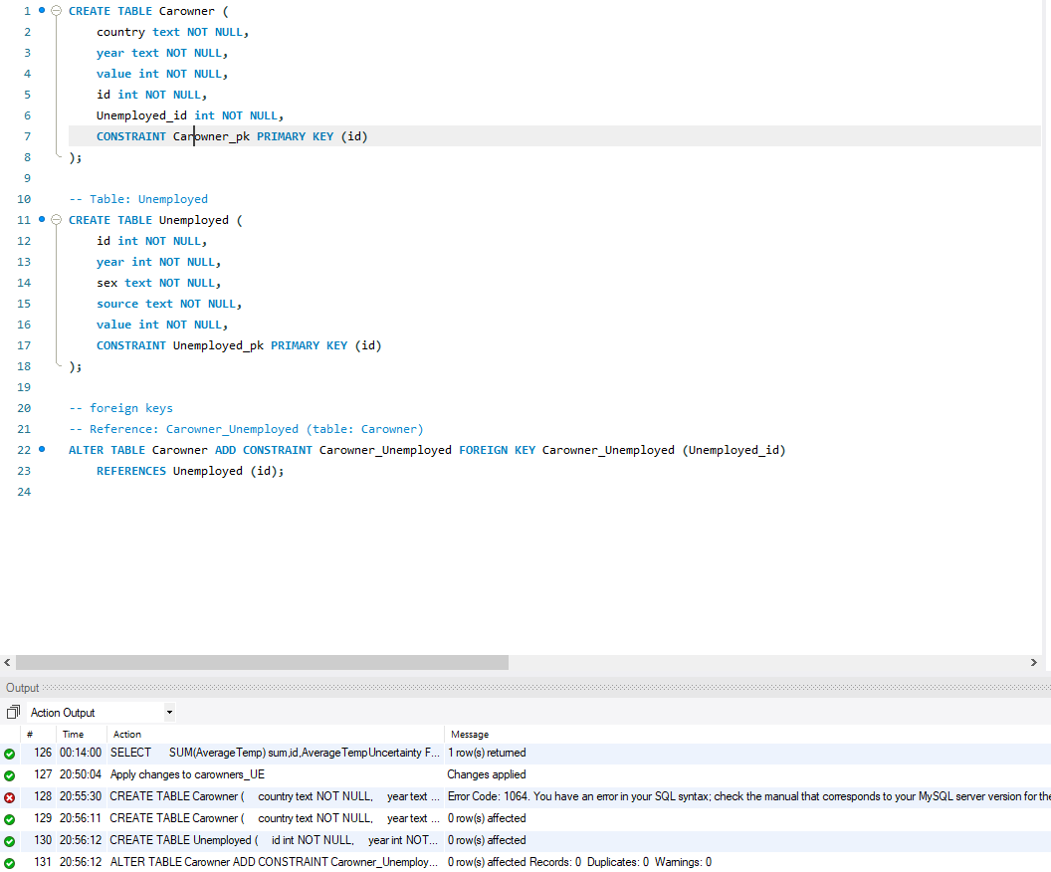

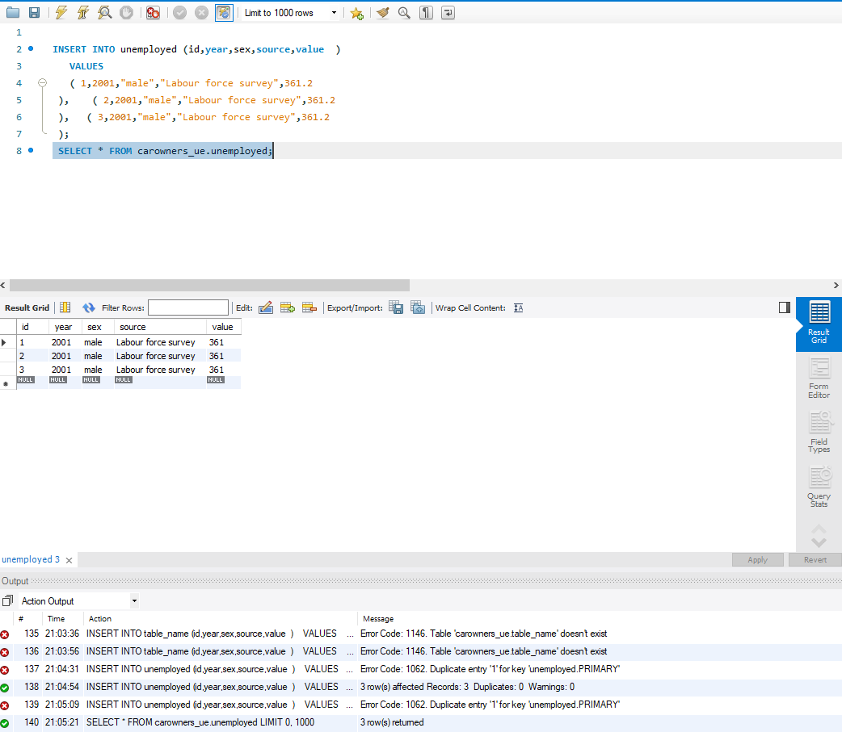

# Data Manipulation Language Scripts

# INSERT COMMANDS

UPDATE COMMANDS:

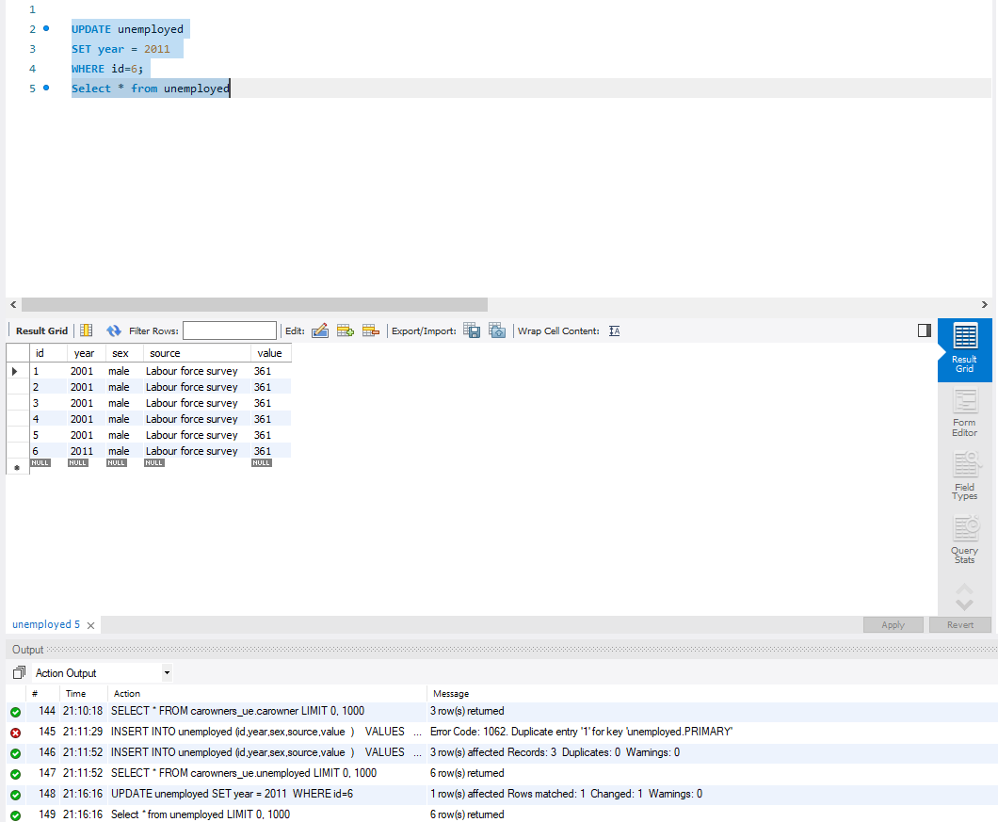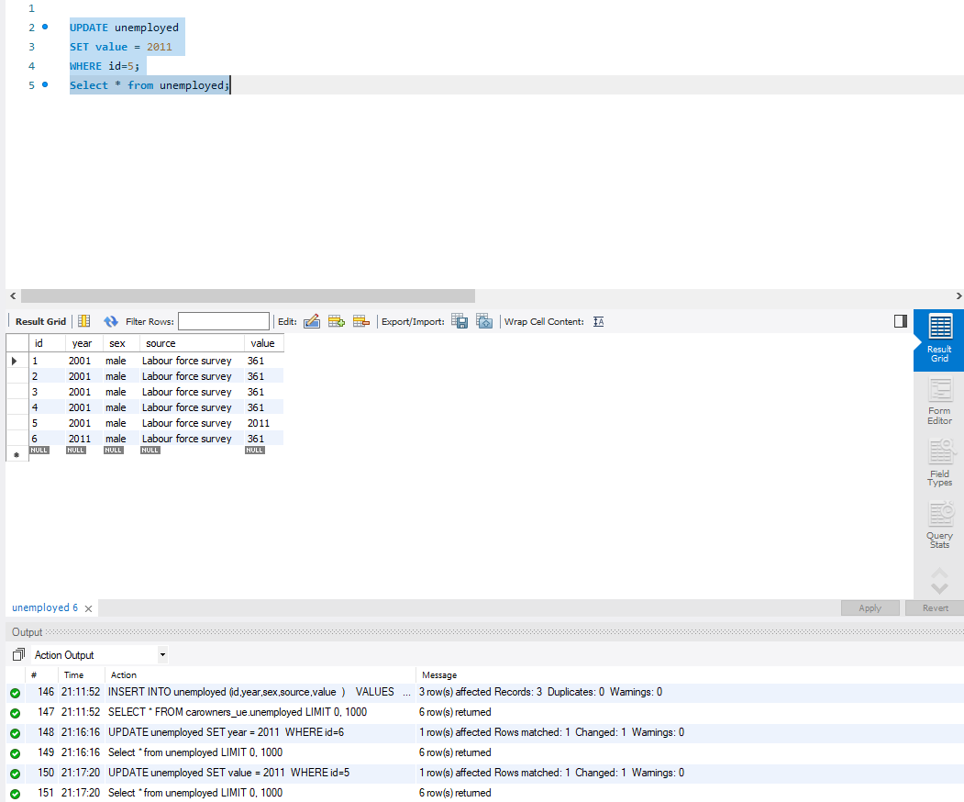

DELETE COMMAND:

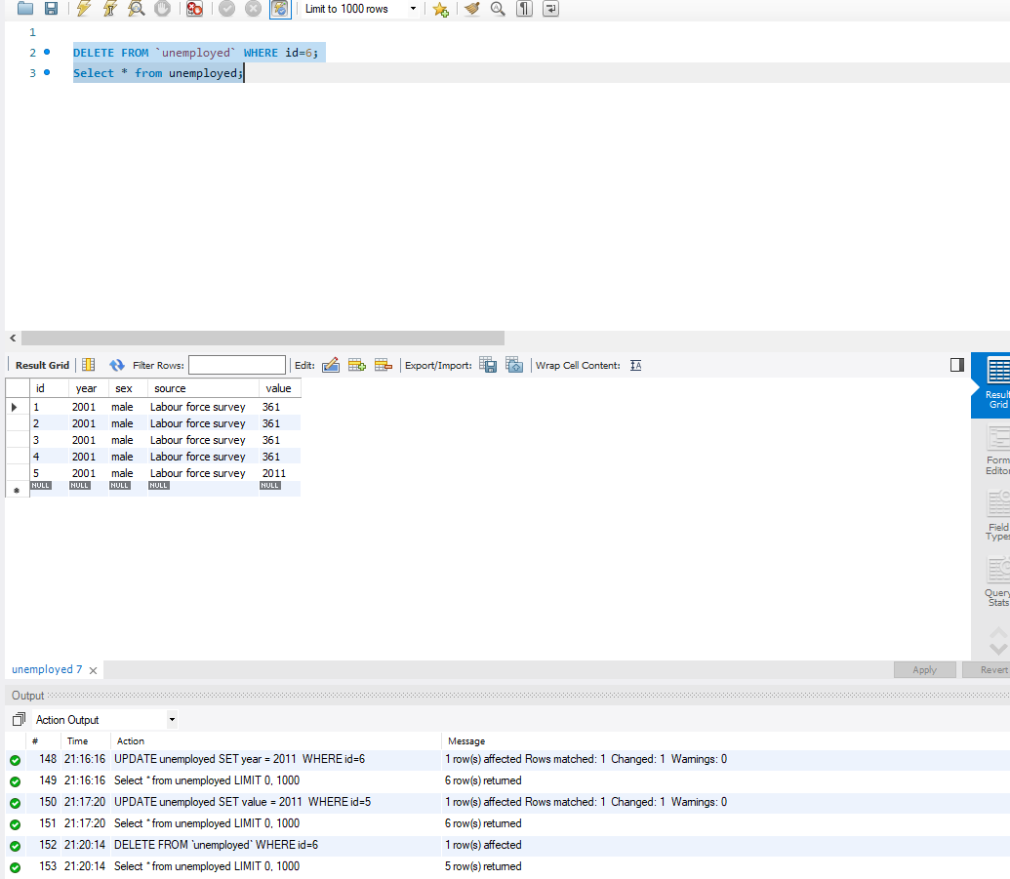

SELECT COMMAND:

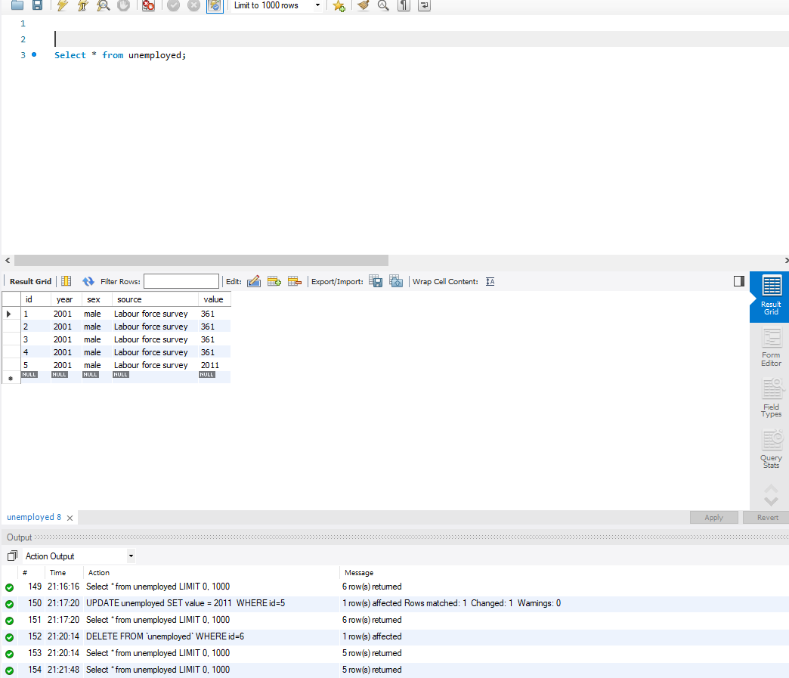

JOIN COMMANDS:  
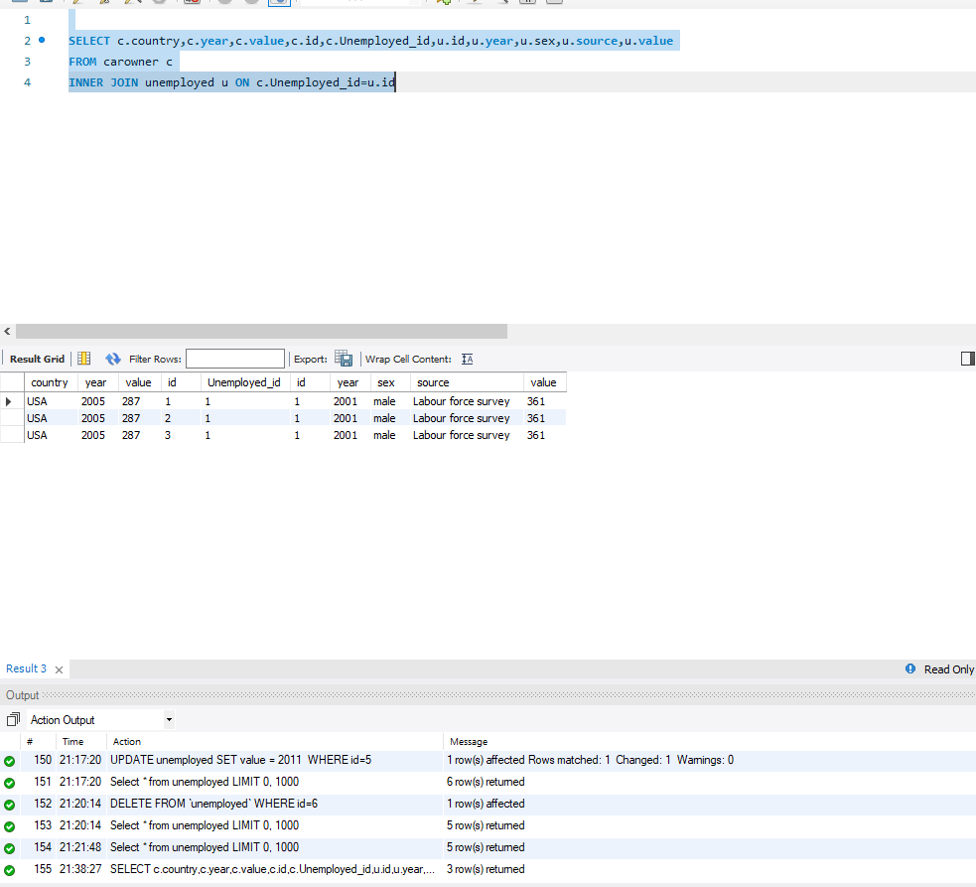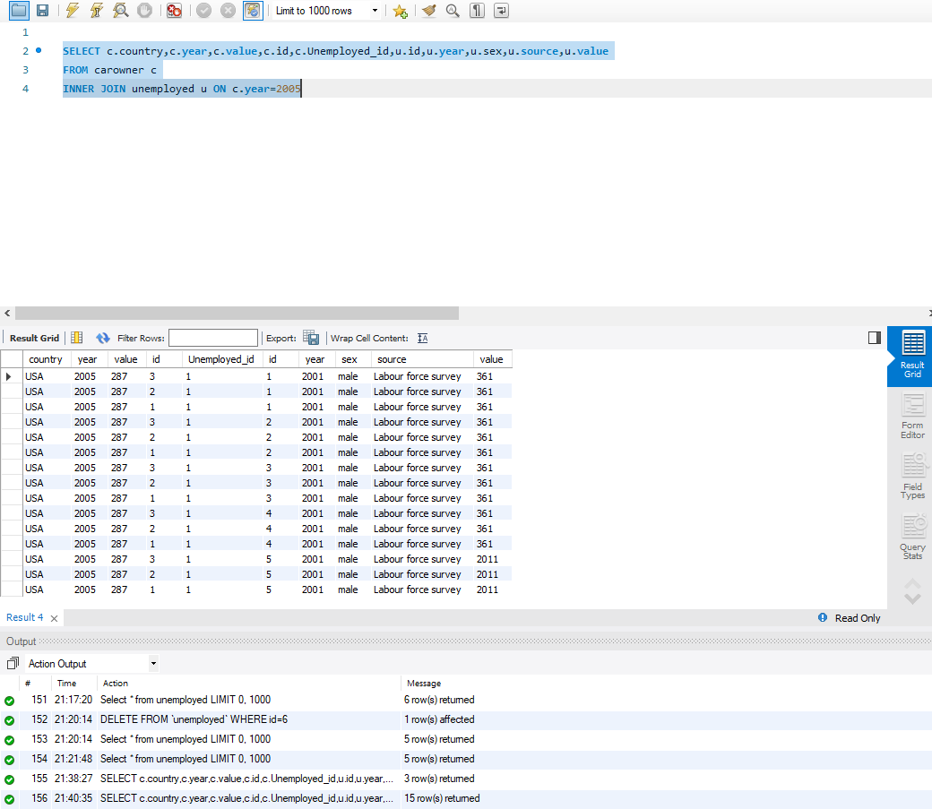

SUMMARY COMMAND:  
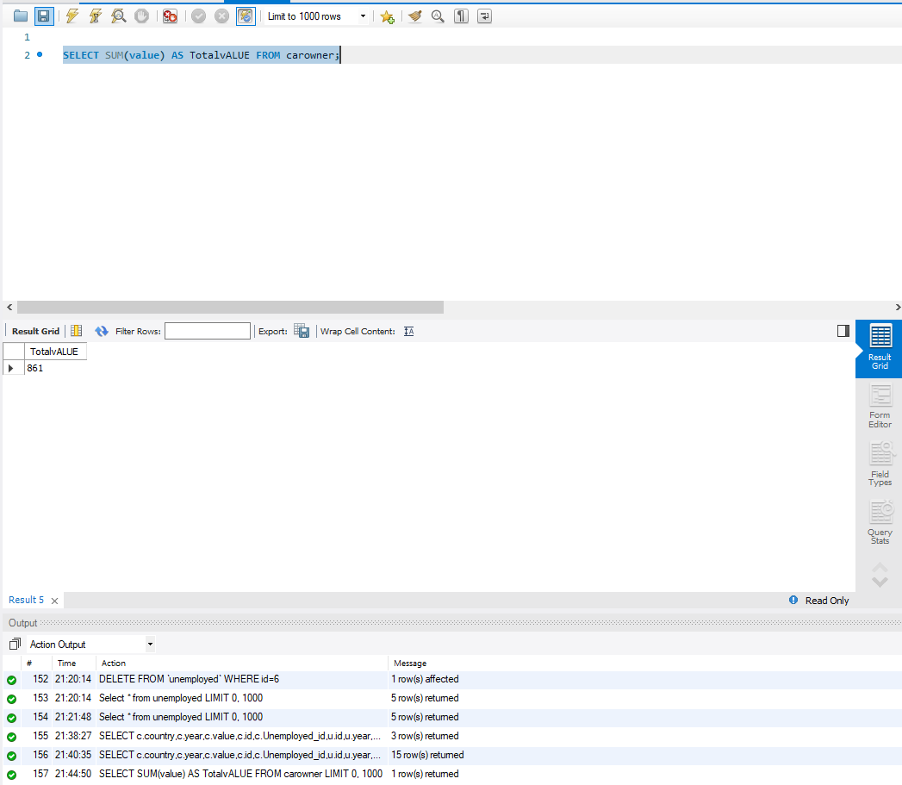

COMMAND OF CHOICE:

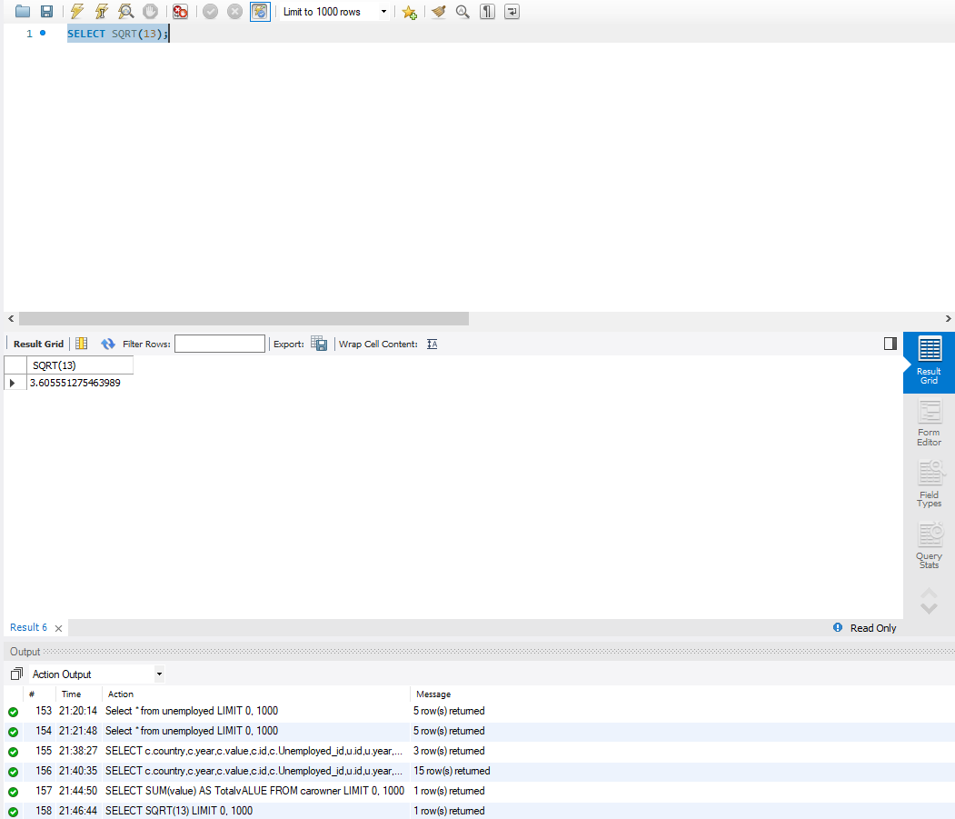

# Indexes

I have created 3 indexes on two tables. The performance improvement will show when the data in these tables will grow. As of now time taken for query is 0.00 seconds.

# Views

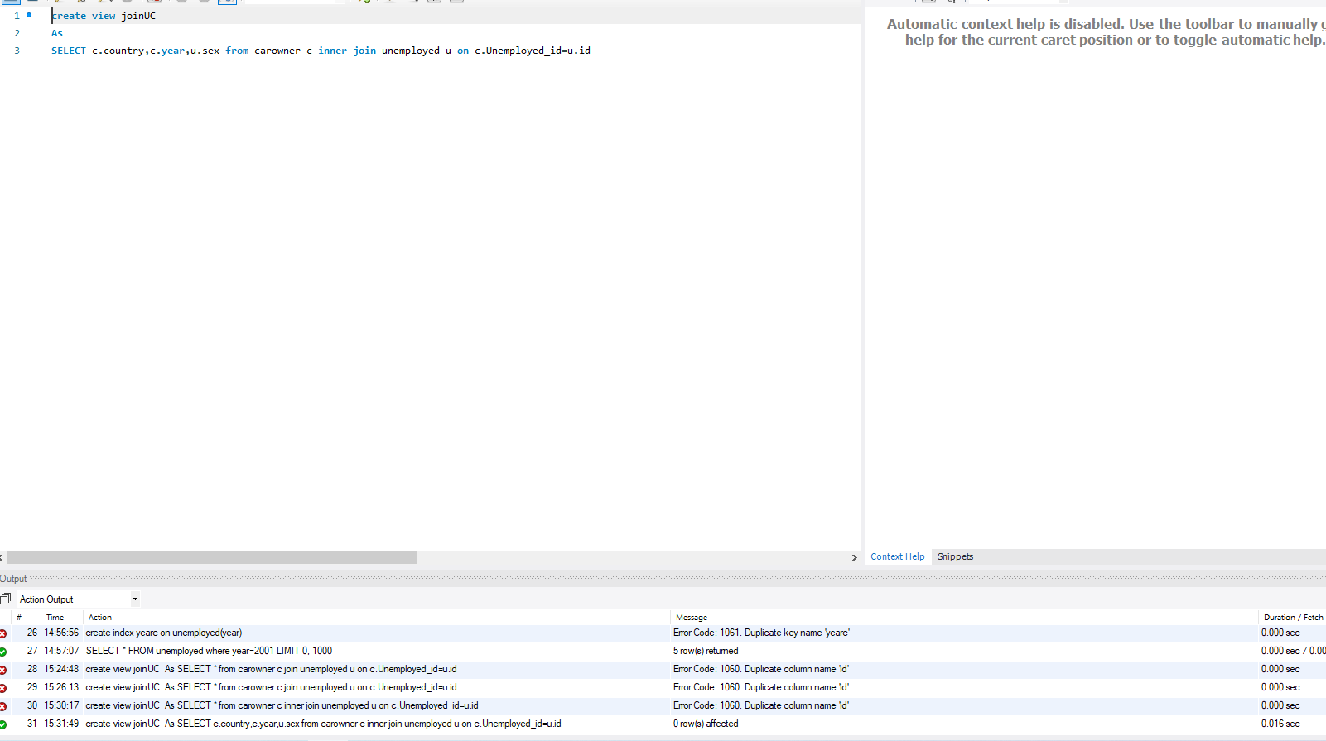

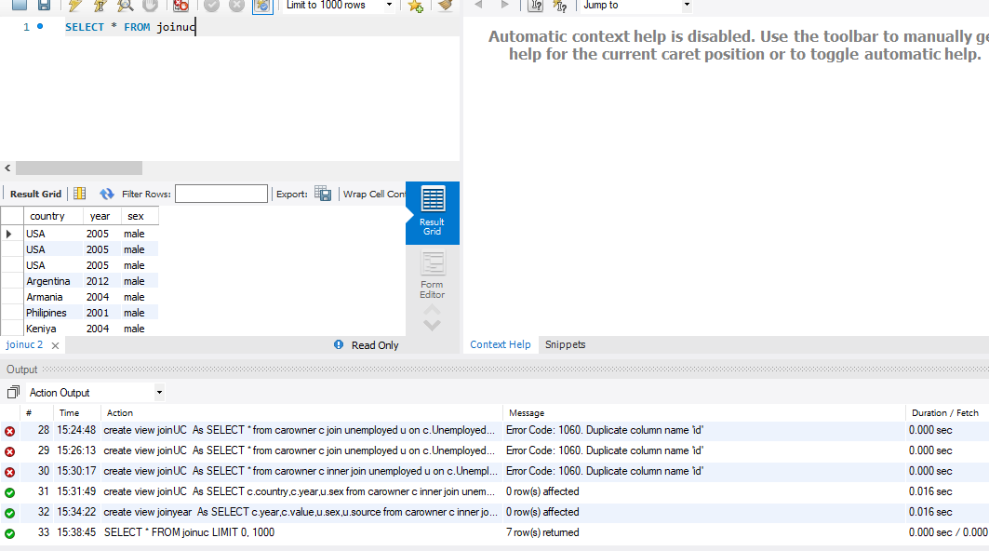

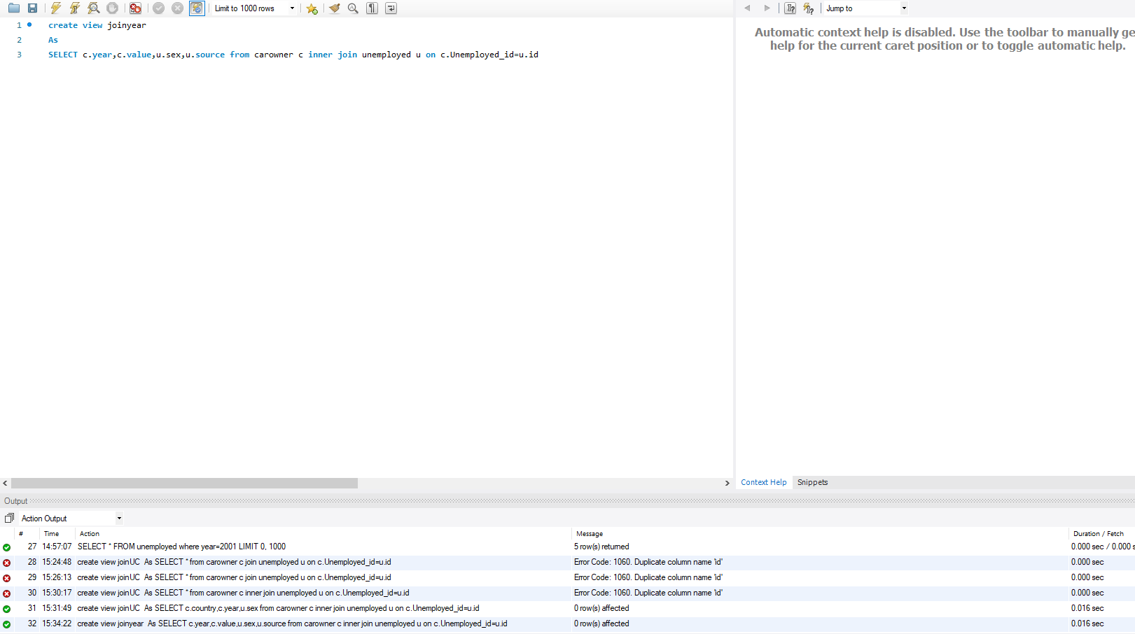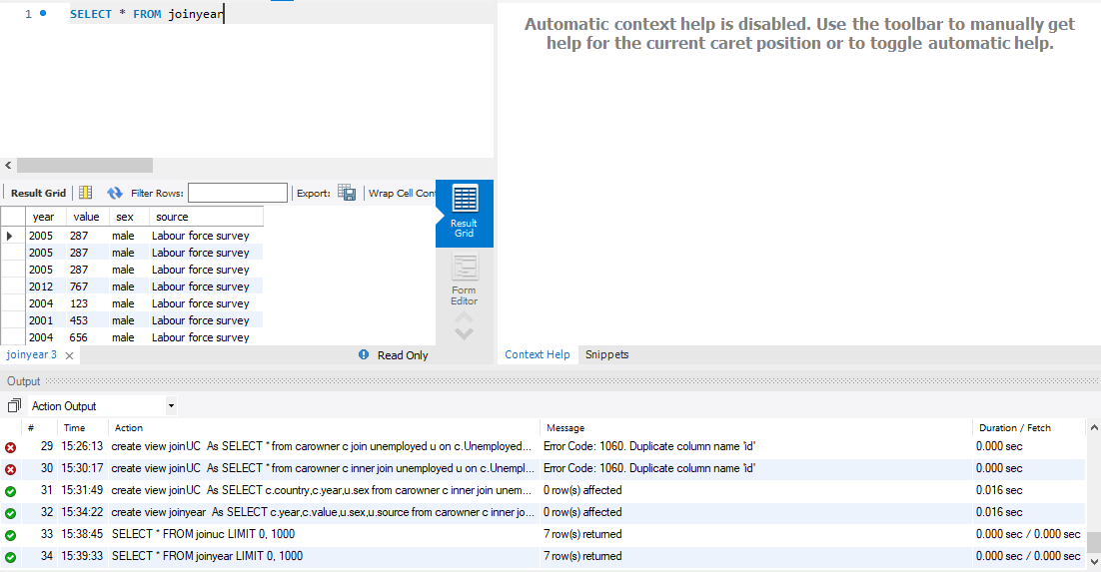

These 2 views are used to store valuable queries for later used getting data

# Triggers

CREATE TRIGGER valueten

before INSERT

ON unemployed

FOR EACH ROW

SET new.value=new.value+10;

Explanation:  
This trigger will add a value of 10 to whatever is being inserted in each row  
 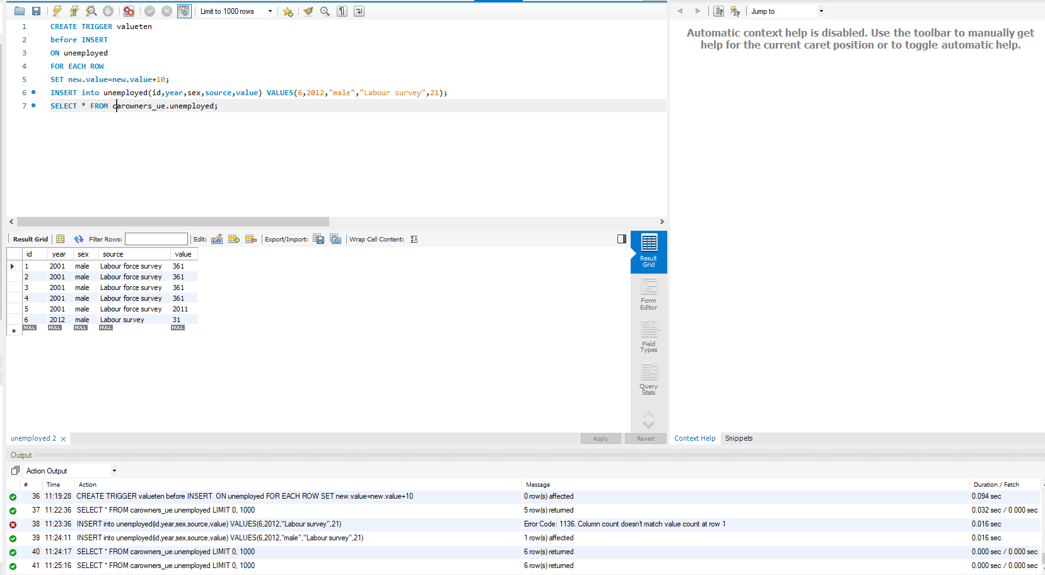

# Transactions

Atomicity in ACID means the transaction exhibit completeness of process. Consistency for correctness, Isolation means that transactions can run at the same time, and durability means that a transaction will not impact the state of data if transaction ends abnormal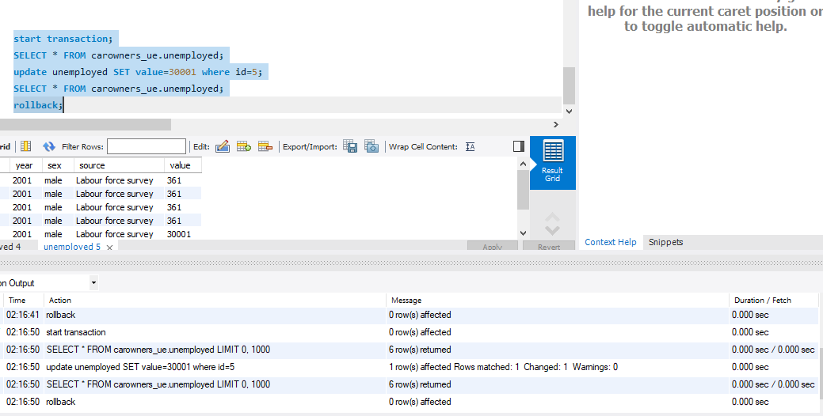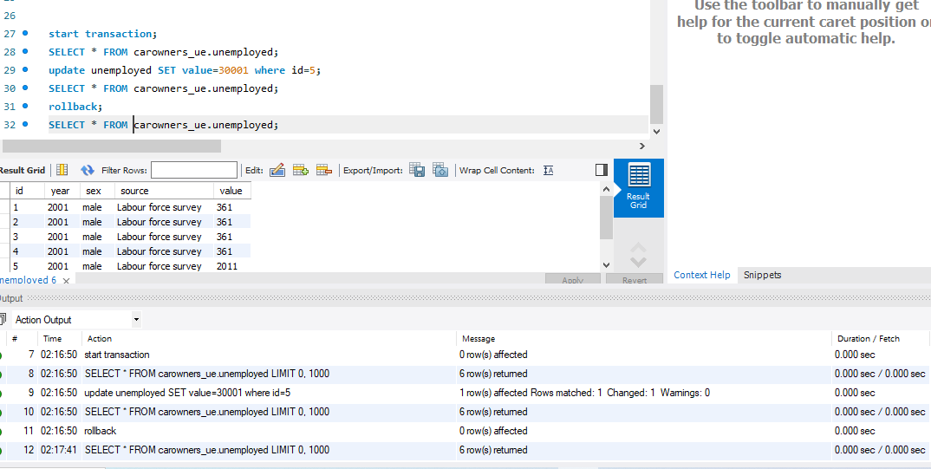

We used a transaction to demonstrate the concept of ACID where until a transaction is committed we can rollback at any time.

# Database Security

David will use the database with all the privileges of a super user including grant.

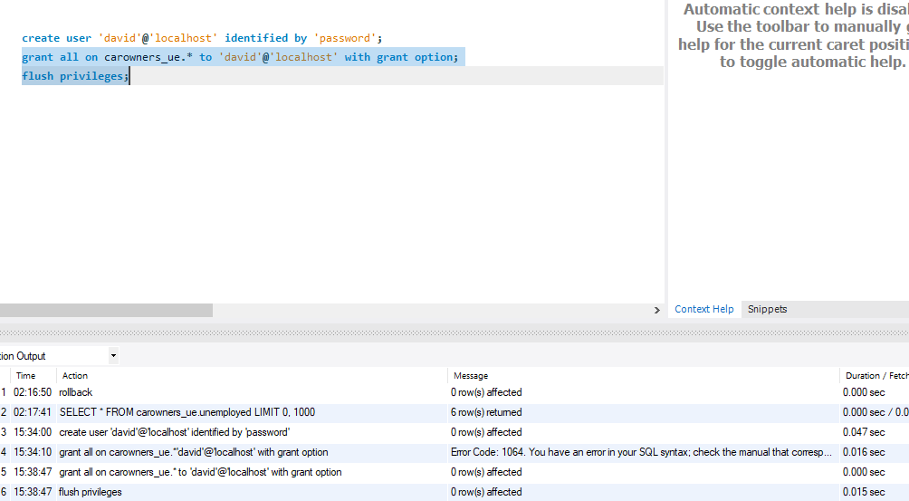

James has privileges of select and insert on all tables in the database  
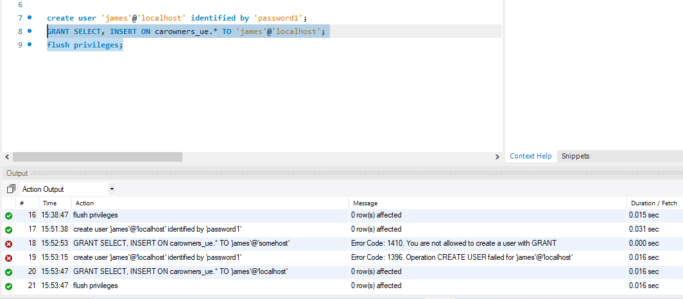

# Locking and Concurrent Access

**MySQL allows a client session to acquire a table lock explicitly to cooperate with other sessions to access the table's data**.

**Locking table write and resultantly other user can’t select anything from locked table  
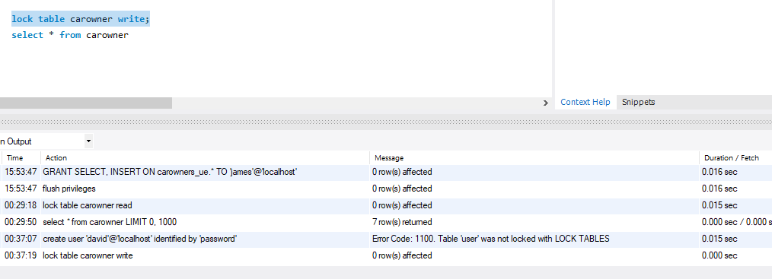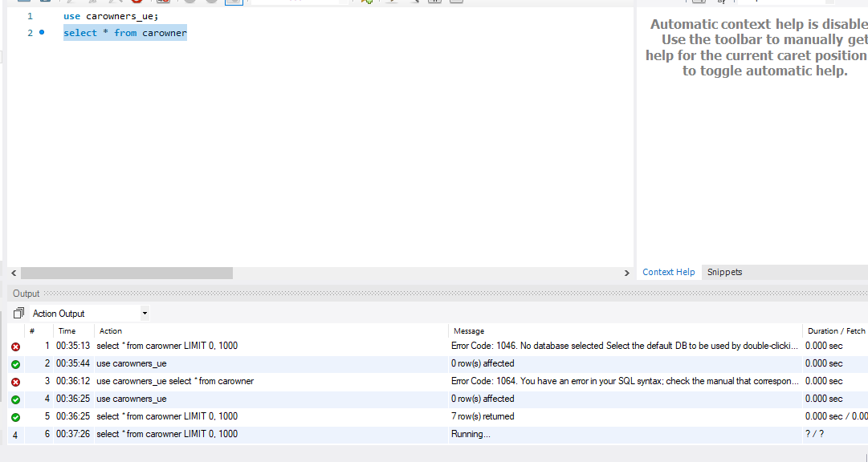**

# Backing Up Your Database

mysqldump -h *localhost* -u *david* -p password *carowners_ue* > *carowners.sql*

# Python Programming

#connector to connect with mysql from python

import mysql.connector

from mysql.connector import errorcode

#a function which will be called to connect with db and execute a query

def select(conn,query):

#a cursor refers to the point of execution

cursor = conn.cursor()

cursor.execute(query)

#list declaration

results = []

#fetches all the records

for row in cursor.fetchall():

results.append(row)

cursor.close()

return results

def execute(conn,query): # update, delete, and insert

cursor = conn.cursor()

cursor.execute(query)

conn.commit()

def show(rows):

for row in rows:

print(row)

#connection attempt

try:

conn = mysql.connector.connect(

user="root",

password="",

host="localhost",

database="carowner_ue")

except mysql.connector.Error as err:

print("Cannot connect.")

exit()

rows = select(conn,"select * from carowner c join unemployed u where c.id=u.id")

show(rows)

print("Now insert a record")

execute(conn,"insert into carowner values ('canada',2016,14,null,1)")

rows = select(conn,"select * from carowner")

show(rows)

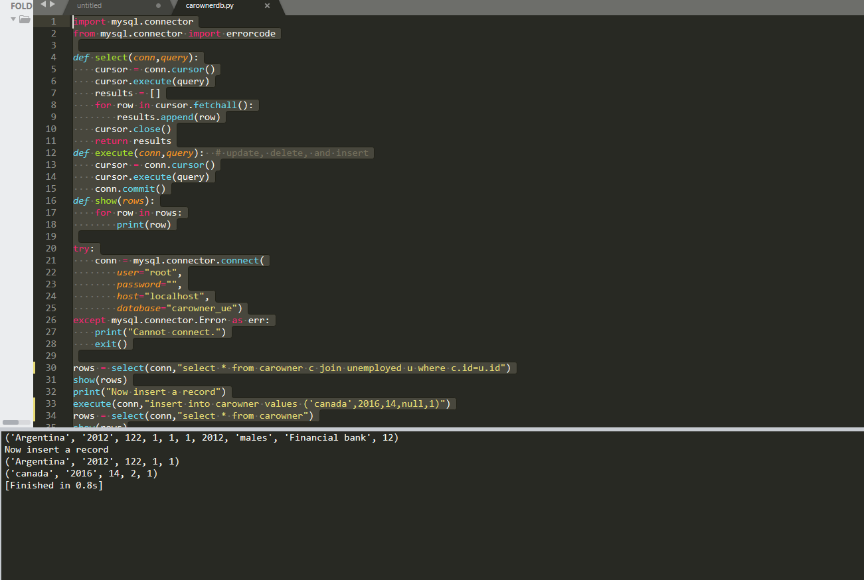

# PHP Programming

Search form and script that returns search results

<form action="search.php" method="POST">

    <input type="text" name="search" placeholder="search" >

    <button type="submit" name="submit">search</button>

</form>

<?php

include_once("config.php");

include_once("Database.php");

$db = new Database();

$db->query("select * from carowner");

$db->query("select * from carowner;");

//$db->bind(':country', "canada"); //'"Ray" or 1=1; --');

$results = $db->resultSet();

echo "enter id to search from database : \n";

foreach ($results as $result) {

    echo "<table>"."<tr>"."<td>".$result->country. "\t" . $result->year . "\t" .

       $result->value . "\t" . $result->id. "\t"."</td>" ."</tr>"."</table>"."\n";

}

$db->query("insert into carowner values ('newzealand',2014,2334,null,1)");

$db->execute();

?>

This shows the search result page and script that translates the search result

include_once("config.php");

include_once("Database.php");

$db = new Database();

?>

<h1>search page</h1>

<div>

<?php

if(isset($_POST['submit'])){

$a= $_POST['search'];

$db->query("SELECT * FROM carowner where

id LIKE '%$a%'

");

$result = $db->single();

// foreach ($results as $result) {

    echo $result->country . "\t" . $result->year . "\t" .

       $result->value . "\t" . $result->id ."\n";

// }

}

?>

</div>

Screenshots that shows the search page and search results

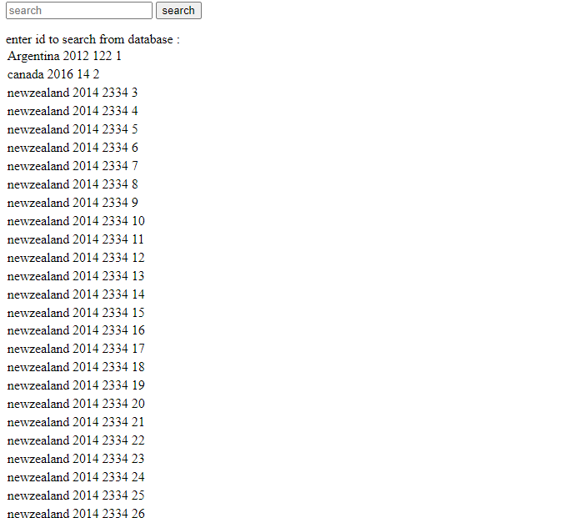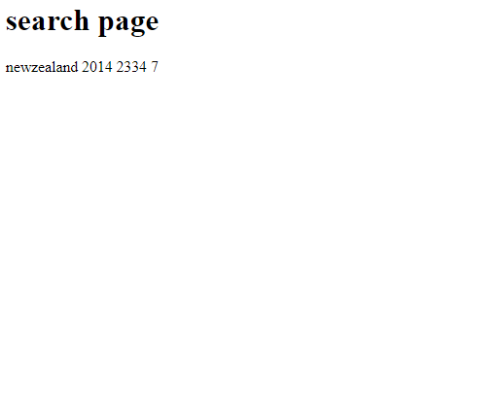

The PDO method is used to prevent SQL injection to happen on any application

# Suggested Future Work

Our database does not yet show patterns.  
It is limited in terms of data storage capacity

We would implement Big data

# Activity Log

Srinivasa Rao decided the data.. Data description was also completed

Srinivasa Rao found the data online

Pranay Reddy Lingapuram researched and described the techniques to store data in relational databases

Srinivasa Rao completed design process.

Pranay Reddy Lingapuram did DDL tasks

Srinivasa Rao completed half of DML commands

Pranay Reddy completed the other half of DML

Srinivasa Rao defined and demonstrated indexes.

Pranay Reddy used views on database.

Srinivasa Rao did triggers, transactions, future work

Prannay completed security, locking, and backup.

Srinivasa Rao used python to perform database operations.

Prannay and Srinivasa worked together on php website to perform search operation on it.